**Assignment 1-2**

**by group 11**

* Alen Kostov
* Timofei Podkorytov
* Yuri Parshin
* Anuraag Deshpande

## **The Intended Functionality:**

The web service is designed mainly to provide a platform for users to post and read reviews, and participate in discussion and ratings of the various food items provided by the university catering service, Scolarest. Apart from a dedicated search bar, there will be categories and several sorting options, to enable the users to find the intended item, and read/write reviews. The items will be broadly categorised as Main menu, sides, salads, desserts, drinks, etc. and may have further subcategories. Each post will contain a rating system that also enables further sorting the items. Our database is intended to be an open platform, which is constantly updated with new posts, discussions and ratings from users and admins alike. The main purpose of this is to create an improvement in the university catering services and in general inform and forewarn users of the food and drinks they will be served.

## 

## **The user can:**

1. search a dish in the database

2. filter the dishes based on certain characteristics they might have

3. add a dish if it is not present

4. rate listed dishes based on personal experience

## **View:**

The main page has a search bar on top and an add button. Below some relevant information from the database can be provided.

If the user decides to search they will see all the results that fit the query and filter toggles that allow to specify the details of the search.

If the user adds an item, they will see fields and toggles to set the details of the dish.

## **Constraints:**

## if no dish satisfies the search query no dish is shown. This applies to searching by name as well as filtering the list.

Rating can only be of a given range like 1 to 5. Name cannot be extremely long (longer than 100 characters). Each dish falls into exactly one end category, that doesn't have children and they do not overlap. All users can leave reviews, but there will be a certain criterion for some users to become ‘critics’, and they will eventually have a separate section in the website. Reviews cannot be empty, and cannot exceed 500 characters, as described by the CHECK statement in the SQL code. All Primary keys such as uid, rid, did, etc. cannot be null by definition.

## **Entity sets: 8**

We have a hierarchy of Relationships: 4 entities that allow us to describe the menu

1. dishes - parent set in ISA hierarchy

- all dishes are drinks or not drinks

1. Non - drinks
2. Drinks

-all non drinks are one of the following 3

1. Main dishes
2. Side dishes
3. Deserts

We also have users and reviews sets

1. Users - can be critics or not and have a id and login
2. Reviews - left by critics

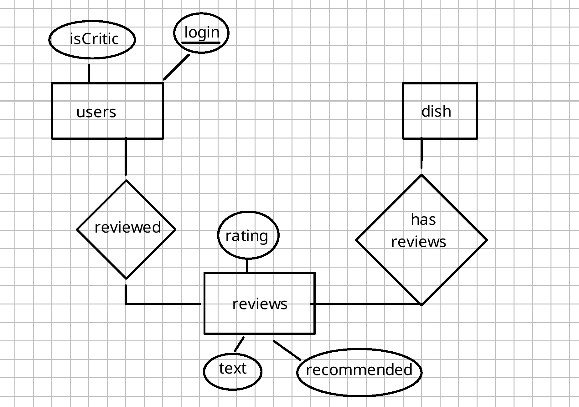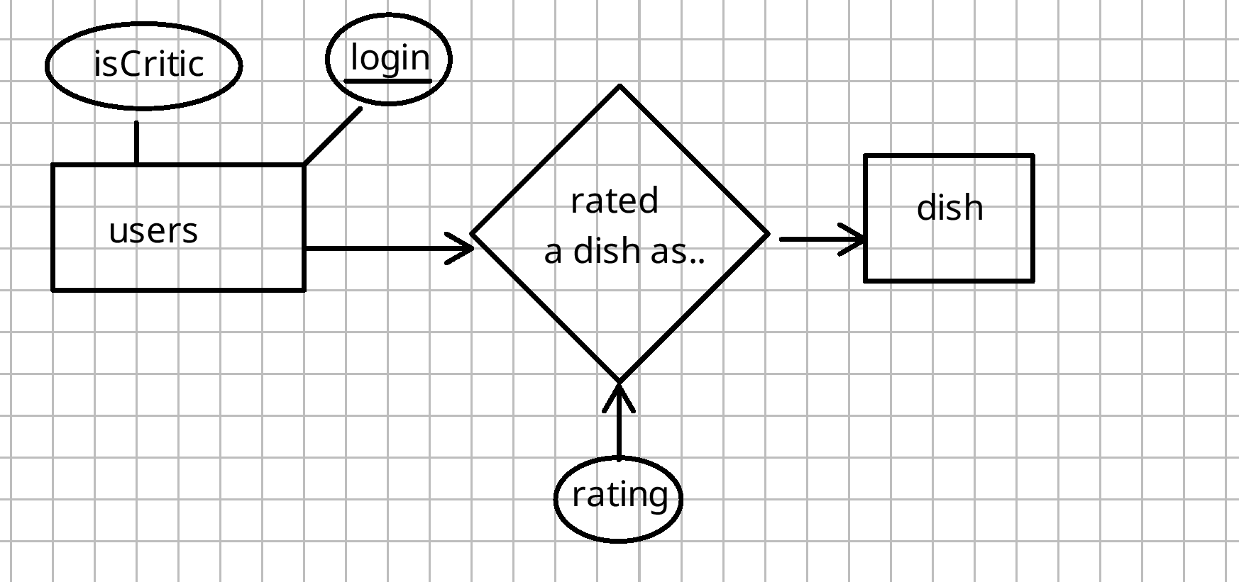

## 

## 

## **ISA: 5**

We have 5 relationships which are depicted on the first diagram. We choose the schema, where the levels are stored separately, as it allows us to have more flexibility, less NULL fields, address the parent class directly and build relationships between different kinds of dishes easier. (Example: goes well with)

## **Relationships: 4**

1. A dish can go well with another dish (DISH -> DISH)
2. A user can rate a dish (USER -> DISH)
3. A user user can review (USER -> REVIEW)
4. A dish can be reviewed (DISH -> REVIEW)

The schema is fully described in the sql document that is also attached. It has the working sql scripts that create entity sets and relations.

